# How to Setup Tests to Run Against Localhost

Right Click on your solution in Solution Explorer and select Set Startup Projects

Set the Action for Portal.Backend.Api and Portal.Web to Start (once you had done this you do not need to set them again, you can just leave them like this)

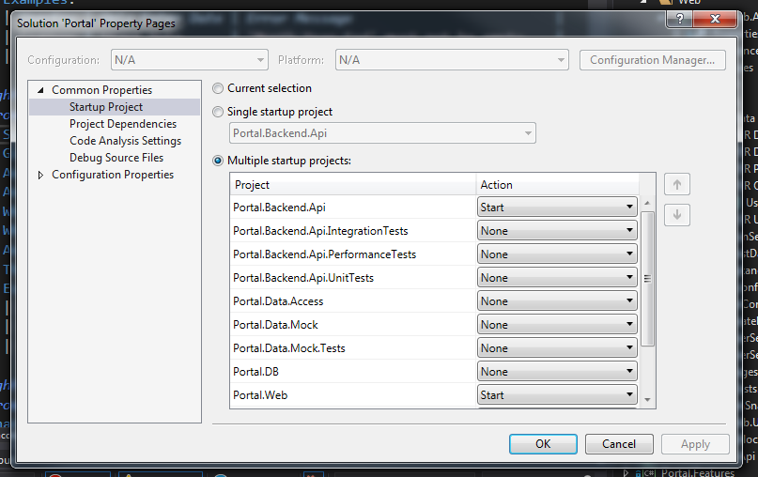

Go to Portal.Web.AcceptanceTests -> acceptance.runsettings in Solution Explorer and set

<Parameter name="WebRoot" value="http://localhost:62017/" />

Go to Portal.Web.AcceptanceTests -> TestData -> RunSettings.cs in Solution Explorer and set

public static string WebRoot { get; set; } = TestContext.Parameters["WebRoot"] ?? "http://localhost:62017/";

From the main menu, select Debug -> Start Without Debugging

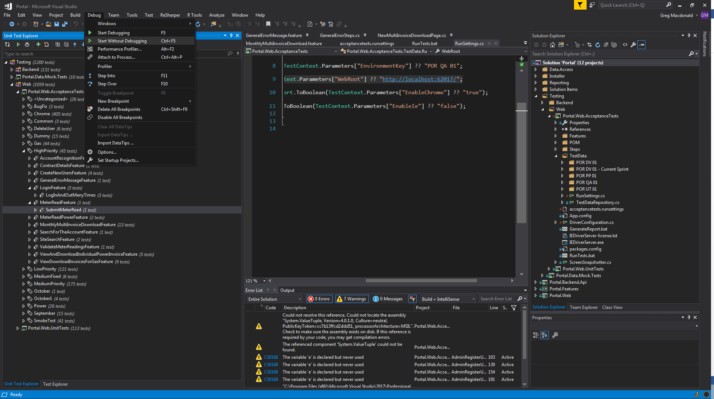

Wait for the Portal Login Page to be displayed in the browser.

Then from Unit Test Explorer right click your test and select Run Unit Tests.

REMEMBER TO RESET THESE PATHS TO <http://porapp01qa/> FOR BOTH OF THESE SETTINGS FILES WHEN FINISHED.